**Introduction**

Addressing climate change and the need for sustainable energy solutions highlights the importance of improving energy systems that integrate long-term infrastructure planning with short-term operations. Optimization models like Calliope are critical for analyzing processes such as energy extraction, conversion, distribution and use (Pfenninger & Pickering, 2018).

This project focuses on developing an AI-driven surrogate model to replicate Calliope’s outputs, including costs and curtailment, while reducing computational complexity. By training on data produced from Calliope simulations, the surrogate model will estimate the relationships between the key inputs and corresponding outputs. Surrogate models make energy system optimization more efficient, enabling faster and larger-scale analyses. This efficiency is especially important in the context of extreme weather events and ambitious decarbonization goals, as these challenges require quick and dependable decision-making (Balduin et al., 2019).

**General work-around**

This diagram shows how the neural network-based surrogate model is created and tested for energy system analysis. Diagram 1 illustrates the setup of the project and outlines the steps that have been undertaken to achieve the results presented in this work. To provide a clearer understanding of the project’s progression, a detailed explanation of the diagram is provided below.

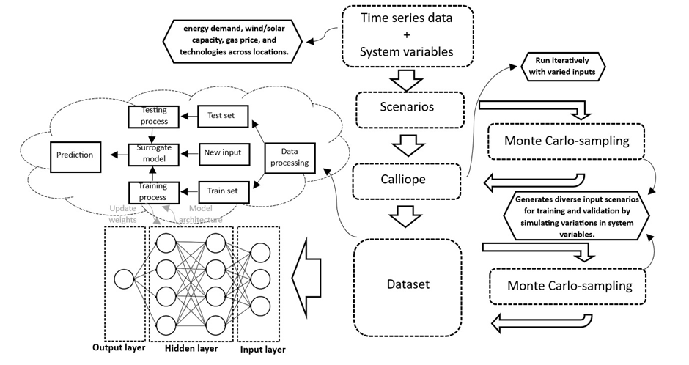

Firstly, time series data and system information are being collected. The energy system data and time series are provided by the supervisor Mr. Lombardi and can be found in the citing down below. The inputs include onshore wind, offshore wind, photovoltaics, and electricity demand. These inputs are used to create various scenarios using Calliope, which will be presented in dataset format. In the next step, Monte Carlo sampling is applied to generate a diverse set of input combinations. This technique is utilized, for instance, with variables such as wind, gas prices, and time. The new scenarios include various combinations, such as wind and time. These newly created scenarios from Monte Carlo sampling are different from the original scenarios and will be used later in the project to develop a surrogate model.

The network itself is made up of an input layer, some hidden layers, and an output layer. During training, the weights in the network are adjusted step by step so the model can learn how the system works. After training, the model is tested with a different dataset to see how well it performs. This helps the model make quick predictions for new inputs. Using this method, it’s much faster to try out different setups and scenarios compared to running a full simulation every time.

**Requirements**

The final products are reached by using Calliope and Kaggle. Calliope is a free and open-source tool that is specifically designed for energy system modeling. Calliope is widely utilized in both research and commercial projects. The framework version which is used in this project is 0.6.10. Before attempting to run this model, it is important to ensure that Calliope is installed. Kaggle is a platform where people can work together by sharing code and other analysis. This is being used in the later part of the project. All the Monte Carlo samplings and other models were made with the help of this platform.

**Overview**

The project includes a Jupyter notebook called *“model_walkthrough”*, which guides new users through the model. It provides examples of how to use the model for tasks like system design or operational analysis and demonstrates how to customize scenarios. This way you can go through all the steps that have been made during this project. It is also possible to get different models as output.

All the input data and model specifications are organized in the in *“model_files”* directory, which includes the following key files:  
 - Calliope  
 - Surrogate  
  
The *"Calliope"* folder is organized into two subfolders: *"timeseries"* and *"results"*. In the *“timeseries”* folder is also a subfolder *“montecarlo”* present which shows all of the Monte Carlo sampled data. This folder contains the generated Monte Carlo data which will be used later on as input again to create more results. Therefore the “timeseries” folder also has a subfolder in which the results are shown, *“results”*. In this folder there are 72 different variations of Monte Carlo sampled data on cost and on curtailment. The *"Surrogate"* folder is split into five subfolders, *"Data Preprocessing", "ML Models"*, *“Neural Network”*, *“input”* and *“results”*. Where the *“input”* subfolder consists of all the data that is used to create the surrogate models. However, *“Data Preprocessing”*, *“ML Models”* and *“Neural Network”* contain the code that is used to find the results that are shown in the subfolder *“results”*. This folder contains a variety of models, including one that predicts wind in relation to monthly costs. All the results were generated using Kaggle. Additionally, the GitHub repository includes a more detailed explanation of the results in a file named *“findings”*.

**Limitations**

The model has several limitations because it is not designed to perfectly represent real-world systems. Here are some of the most important limitations:

* The measurement locations have been simplified, potentially limiting the diversity of data collection.
* Not all desired features, particularly those listed as "Could Have" requirements, may be implemented due to resource and time constraints.
* Limited time is available for the development and testing phases of the model, which may restrict opportunities for refinement and optimization
* There is limited technical expertise in key areas, which could impact progress in certain aspects of the project.
* Due to the limited amount of technologies some results are not that different from others.

**Authors**

Sara Sorici  
 E-mail: s.sorici@student.tudelft.nl  
 Wouter Bosse  
 E-mail: w.bosse@student.tudelft.nl  
 Mark van Egmond  
 E-mail: m.vanegmond@student.tudelft.nl  
 Lore Tollenaar  
 E-mail: l.tollenaar@student.tudelft.nl  
 Jelle Overdijkink  
 E-mail: j.h.overdijkink@student.tudelft.nl  
 Geert Arends  
 E-mail: g.a.arends@student.tudelft.nl

**Citing**

Balduin, S., Oest, F., Blank-Babazadeh, M., Nßie, A. & Lehnhoff, S. (2019). Toos-assisted surrogate selection for simulation models in energy systems. Proceedings of the Federated Conference on Computer Science and Information Systems, 185-192. From: <https://doi.org/10.15439/2019F242>

Lombardi, F. (2024). *Calliope-Nl*. From: <https://github.com/FLomb/Calliope-NL/tree/main>

Pfenninger, S. & Pickering, B. (12 september 2018). From: <https://calliope.readthedocs.io/en/stable/user/introduction.html>

Stefan Pfenninger and Bryn Pickering (2018). Calliope: a multi-scale energy systems modelling framework. *Journal of Open Source Software*, 3(29), 825. From: [doi:10.21105/joss.00825](https://doi.org/10.21105/joss.00825)

Disclaimer:  
In this project the AI ChatGPT is being used to assist with coding and to check grammar on some parts of the report.

**License**

Copyright 2024 Calliope-NL, contributors listed in Authors

This work is licensed under a [Creative Commons Attribution-NonCommercial-ShareAlike 4.0 International License](http://creativecommons.org/licenses/by-nc-sa/4.0/).

Unless required by applicable law or agreed to in writing, software distributed under the License is distributed on an "AS IS" BASIS, WITHOUT WARRANTIES OR CONDITIONS OF ANY KIND, either express or implied. See the License for the specific language governing permissions and limitations under the License.